**1066 Battle of Hastings Study Day**

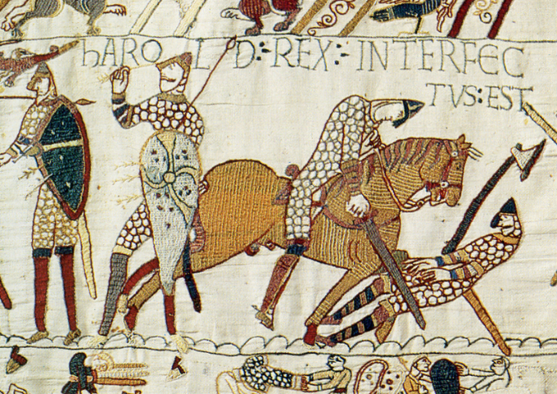

**Saturday 15 October 2016**

**10.00-16:00**

**Lecture Theatre C**

**Building 65**

**Avenue Campus**

|  |  |
| --- | --- |
| **10:00** | **Coffee** |
| **10:10** | **Welcome** |
| **10:15** | **The Bayeux Tapestry**  *Professor David Hinton, University of Southampton*  The Bayeux Tapestry is actually an embroidery, and may not have been made or intended for display in Bayeux; such points exemplify why it is a difficult source to use for interpretation of the Battle of Hastings. Just as Domesday Book, its near-contemporary, is a unique survival record of manorial resources in late eleventh-century England, so too the Tapestry is a unique surviving record: a long illustrated sequence of pictures of an episode in the history of England. Its first scene shows Edward the Confessor with Earl Harold, a scene which is immediately invites controversy because the reason for their meeting is not explained. Was Harold being instructed to go to Normandy, to offer the English crown to Duke William, or was he requesting permission to go overseas for some purpose of his own?  Problems of interpretation arise throughout the sequence; is the focus on Harold and his fate, or the triumph of Duke William? Views about the meanings underlying each picture colour discussion of the significance of every detail, whether it is the main scenes or the border details, and the extent to which accurate recording can be expected in the composition. |
| **11:00** | **Writing and Reading Hastings: Making Sense of the Sources**  *Dr Leonie Hicks, Canterbury Christ Church University*  Nearly as much ink has been spilled as blood was on the field itself in attempts to analyse and describe what happened on 14 October 1066, better known as the Battle of Hastings, where William of Normandy killed King Harold and took the English crown. Hastings was a significant and unusual event. Pitched battles were rare in the eleventh century and the conclusion saw the replacement of an entire ruling class. It is unsurprising that historians have scoured the accounts of the battle in order to reconstruct the tactics used by the two armies and the events of the day and that virtually all the text books include a description that tries to reconcile the different accounts written by English and Norman chroniclers to get to the truth of what actually happened.  ‘What actually happened?’ is, in fact, the wrong question to ask. No eye witness account survives, only echoes in other sources. In understanding Hastings, we need to ask ‘what do we know?’ The one thing all the medieval writers agree on is that Harold was killed. This was the key moment on which the outcome of the battle was determined and with it the fate of the kingdom. Many of the questions posed about Hastings such as the number of times the Normans pretended to run away to lure the English from their defensible position or how Harold died are unknowable. Medieval warfare was as confusing and bloody as anything in modern history and armies did not have embedded reporters who issued regular bulletins on campaign. Instead of reading the accounts of Hastings literally, we need to think instead about what they reveal about the way medieval writers understood their world, the place of the Normans in it, and how the undoubtedly traumatic events of 1066 were understood in later generations. |
| **11:45** | **Coffee** |
| **12:00** | **1066: The Death of Anglo-Saxon England?**  *Professor Catherine Clarke, University of Southampton*  The death of Harold at Hastings in 1066 led to a Norman king on the English throne, a new Norman nobility in England and the transfer of land, power and wealth across the country into Norman hands. But what did 1066 mean for Anglo-Saxon cultural identity – and, in particular, the rich vernacular traditions of Old English language and literature?  This presentation will look at the great flowering of Old English culture – including the epic poem Beowulf – in the decades before the Norman conquest, and the evidence in literature and language for the marginalisation and suppression of Anglo-Saxon cultural traditions in the later 11th century and onwards. Continuations of the Anglo-Saxon Chronicle and poems such as Durham (c.1104-1109) are sometimes understood as a kind of ‘guerrilla literature’, resisting Norman power through native traditions and cultural memory.  Should we see 1066 as a catastrophic rupture in English culture, and the end of Anglo-Saxon traditions? Or do the literary and manuscript survivals tell different stories, about continuity and development? |
| **12:45** | **Lunch** |
| **13:45** | **Domesday Book and the Norman occupation of England**  *Dr Nicholas Karn, University of Southampton*  In 1086, almost at the end of his reign and life, William the Conqueror commissioned a great survey of England that gave rise to the famous Domesday Book, the most detailed survey of any medieval kingdom, and long regarded as an icon of English history. Domesday Book is so detailed that it allows an understanding of even the smallest villages; it allows us to move beyond the world of high politics and look at the real lives and struggles of everyday life in eleventh-century England. This talk will cover three main themes: what was Domesday Book for and what information does it contain? how was Domesday Book made? and what does it tell about the Norman conquest and occupation of England? All are important, but the latter is the most crucial, for Domesday Book alone can give an impression of how the Norman Conquest was experienced across England, and how it affected the lives of those outside the ruling and fighting elite. It shows in detail how political power was transferred from English to Normans, and how people responded to these developments. |
|  |  |
| **14:30**  **14:45** | **Coffee**  **Castles and the Norman Conquest**  *Dr Dan Spencer, University of Southampton*  The triumph of the Normans at the battle of Hastings was a decisive victory for Duke William, which led soon afterwards to his coronation as king of England on Christmas Day 1066. However, the new ruler faced many threats to his rule. In the following years, English discontent led to the outbreak of major rebellions throughout the kingdom, with the rebels receiving periodic support from Sweyn II of Denmark. William was ultimately able to quell these uprisings as a result of extensive military campaigning, but the conquest of England was ultimately secured by the construction of new fortifications called castles. The chronicler Orderic Vitalis, writing later in the twelfth century, claimed that English ignorance of these structures meant that they ‘in spite of their courage and love of fighting - could put up only a weak resistance to their enemies’.  This talk will discuss the introduction of the castle to England and their role in the Norman Conquest. It will begin by examining the origins of the castle in northern France, before exploring the evidence for Norman castle building in England and their role in the military campaigns of William I. |
|  |  |

**15:30 Questions and Discussions**

**16:00 End of Day**

*Please do not forget to hand in your feedback form at the end of the day. Thank you!*